FREELANCE PROPOSAL & FEEDBACK HUB
@CREATIVITY THINK (9483175986/7019689991)

ABSTRACT:
Freelance Proposal & Feedback Hub is a dynamic web-based platform designed to streamline interactions between freelancers, clients, and agencies. The system allows clients to post project briefs, freelancers to submit proposals, and both parties to track project history and feedback. With advanced features such as proposal templates, feedback ratings, analytics dashboards, and category-wise statistics, this platform enhances transparency and professional collaboration. Built using Django REST Framework and React with Redux, the system offers a seamless user experience supported by real-time data handling and modern interface design..

INTRODUCTION OF THE PROJECT:
Freelancers and clients often face inefficiencies when managing project briefs, proposals, and feedback across multiple channels. Traditional communication methods like emails or chat apps lack structure, transparency, and long-term statistical insights.
The Freelance Proposal & Feedback Hub solves these challenges by providing a centralized communication and management platform where freelancers can submit proposals using pre-defined templates and clients can evaluate, compare, shortlist, and accept proposals. After project completion, ratings and feedback build credibility and improve future decision-making. Analytics dashboards further help identify in-demand categories and success rates for freelancers..

PROJECT OBJECTIVES:

• Provide a professional system for posting project briefs and submitting proposals
• Offer proposal templates that freelancers can customize
• Enable clients to compare proposals and select the best fit
• Allow feedback ratings after project completion
• Maintain history logs for both freelancers and clients
• Provide dashboards with analytics such as win rates and performance
• Allow admins to moderate proposals, briefs, and address abuse reports
• Manage a centralized library of proposal templates
• Offer exportable performance reports

PROBLEM OF THE STATEMENT:
Managing freelance proposals across messaging apps and emails leads to confusion, lost information, and inefficiency. Clients struggle to compare proposals, while freelancers lack insights into performance data and category demand. The absence of structured feedback makes credibility assessment difficult.
This project solves these issues with a centralized hub that handles proposal submissions, feedback ratings, and controlled moderation, ensuring transparency, structure, and data-driven insights..

MOTIVATION OF THE PROJECT:
• To provide a structured platform for freelancers and clients
• To simplify proposal creation with reusable templates
• To enhance credibility with client feedback ratings
• To give freelancers valuable performance analytics
• To support clients in comparing proposals and making informed decisions
• To ensure transparency and prevent misuse through admin moderation
• To digitalize freelance workflow into a single dashboard-driven application

BLOCK DAIGRAM OF PROJECT:

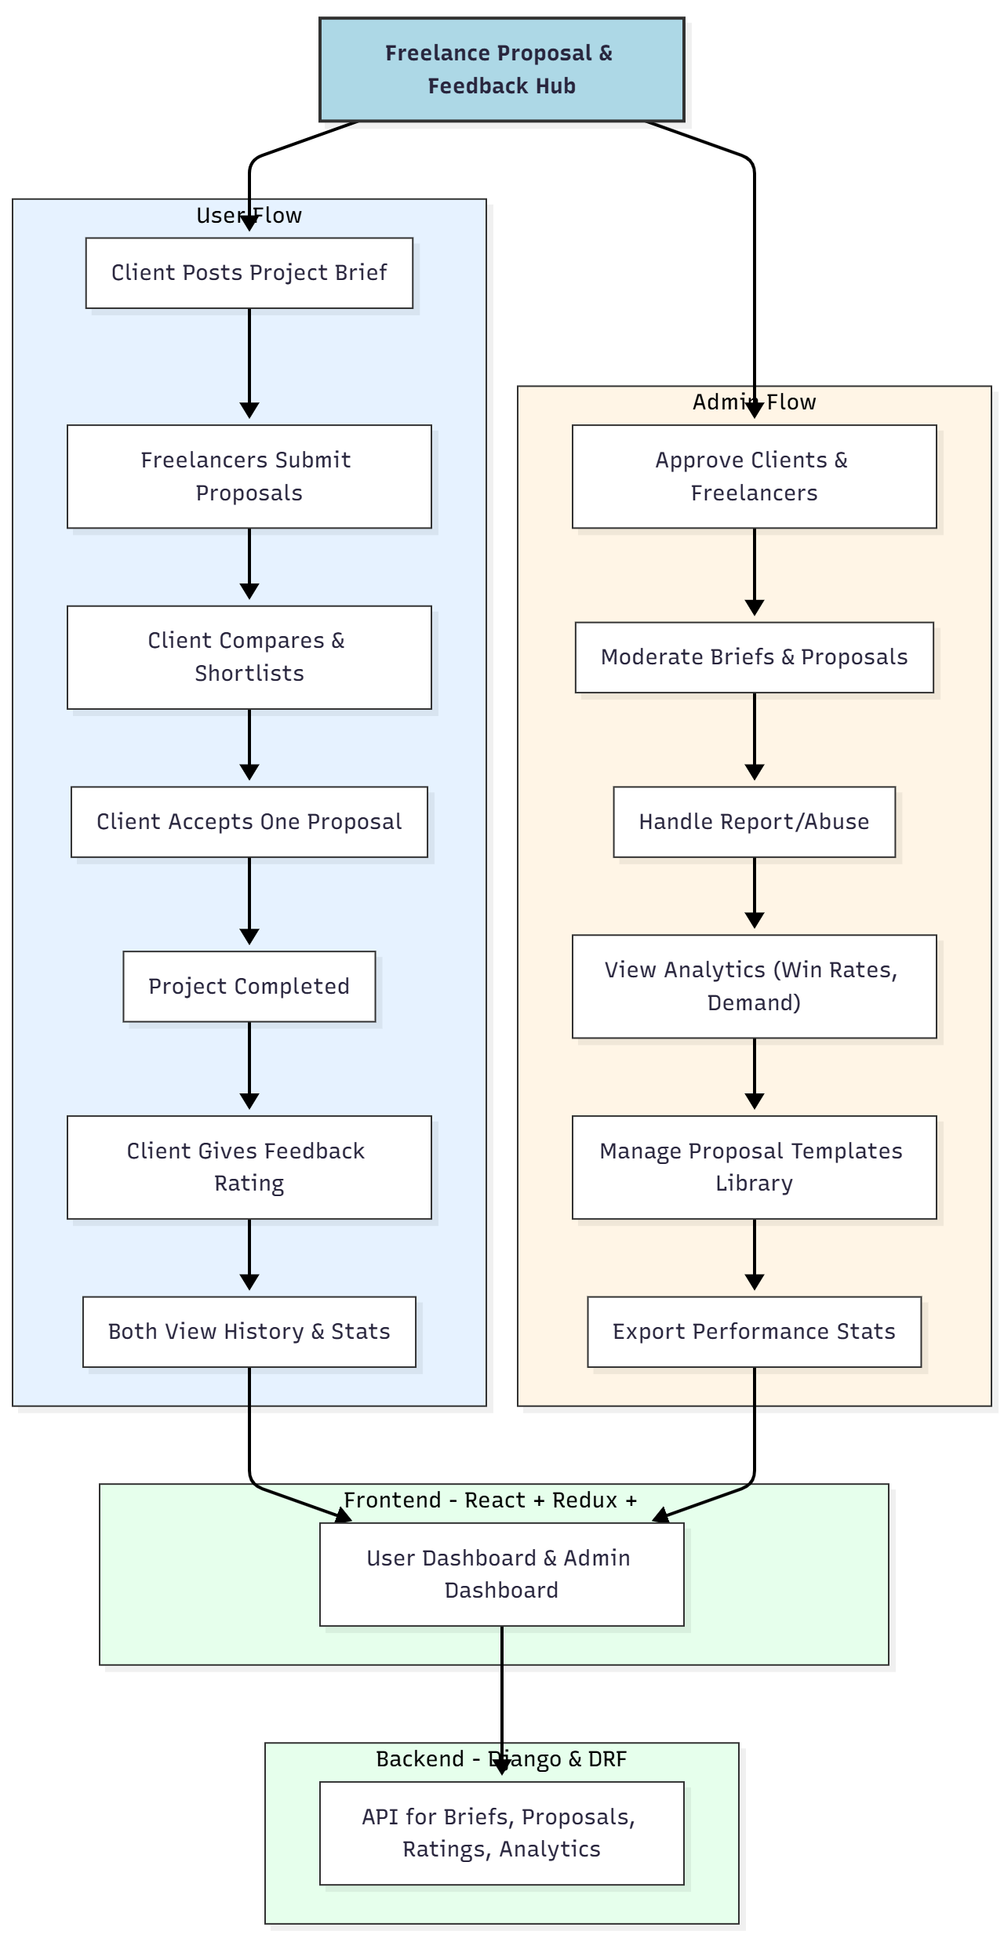

WORKING OF THE PROJECT:
Clients begin by creating a detailed project brief, which becomes visible to registered freelancers. Freelancers can choose a proposal template from the library or create a new one, then submit their proposal for the project.
Clients can compare all received proposals, shortlist candidates, and finally accept one. Once the project is completed, the client provides feedback and a rating which improves the freelancer’s credibility.
Users can view all past proposals, accepted work, and ratings through their dashboards.
Admins supervise the entire system—approving clients and freelancers, moderating project briefs, tackling abuse reports, managing proposal templates, and generating exportable analytics such as win rates and trending categories..

SOFTWARE REQUIREMENT:
- Backend:
  - Python 3.x
  - Django
  - Django REST Framework
  - SQLite/PostgreSQL
- Frontend:
  - Node.js and npm
  - React.js
  - Axios
- Development Tools:
  - Visual Studio Code
  - Postman (for testing APIs)
  - Git/GitHub (for version control)
- Server/Deployment (Optional):
  - Gunicorn, Nginx, or Heroku/AWS for hosting

ADVANTAGES OF THE PROJECT:

• Clean and structured management of freelance proposals
• Centralized communication between clients and freelancers
• Reusable proposal templates save time
• Feedback ratings improve trust and credibility
• Data insights like win rates increase freelancer performance
• Admin moderation prevents abuse and maintains quality
• Dashboard analytics help identify high-demand categories
• Exportable performance logs for freelancers and clients

APPLICATIONS OF THE PROJECT:
• Freelancers (developers, designers, writers, etc.)
• Small digital agencies
• Startups seeking quick proposals
• Clients needing organized decision-making
• Professional service marketplaces

REFERENCES:

- Django REST Framework Documentation — Django Software Foundation. Django Documentation. Available: https://docs.djangoproject.com/
- Django REST Framework. DRF Documentation. Available: https://www.django-rest-framework.org/
- React. React Official Documentation. Available: https://reactjs.org/docs/getting-started.html
- Redux. Redux Documentation. Available: https://redux.js.org/introduction/getting-started
- PostgreSQL Global Development Group. PostgreSQL Documentation. Available: https://www.postgresql.org/docs/
- MySQL. MySQL Reference Manual. Available: https://dev.mysql.com/doc/
- Git. Git Documentation. Available: https://git-scm.com/doc
- Node.js. Node.js Documentation. Available: https://nodejs.org/en/docs/
- Axios. Axios Documentation. Available: https://axios-http.com/docs/intro
- Socket.io Documentation – https://socket.io/docs/

